Plan for Deep Learning Final Submission
Feedback: Correct proposal overall, although in its current form it lacks a bit of originality. For the next submission, fix windows-level data leakage. Be careful with patients 1 and 21 for the patient-level split, they are the same person. Work on the temporal model

- Fix Windows-Level Data Leakage (Augmentation Overlap)

- Augmentation of the data means windows have redundant and repeating data (80% overlap), so it means adjacent windows are nearly identical
- For the window-level model: patient leakage is OK (that’s the point), but we need to ensure that the Test set doesn’t contain neighbors of any of the windows in the Train set
- Algorithm – helpers/splits.py
  - Randomly sample windows for Test set.
  - Then discard all the windows that are 80% overlapped with the windows within the Training set
  - Randomly select the remaining windows for the Train set.

- Fix Patient-Level Split - Patient 1 and 21 are the same person

- Merge chb01 and chb21, or keep them together for patient split
- Fix: add a rule in the code that re-labels all chb21 data as chb01, so their recordings stay strictly together in either the training pile or the test pile.

- Double check the balanced-unbalanced protocol and just pick one for the temporal model
- We have too many combinations of balanced-unbalanced test-train. The 3x2x2 design will be 3x2x2x2 if we want to compare the LSTM / temporal method.
- For the temporal model (LSTM or whichever method), we should just pick which regime was better in the CNN and use that for the LSTM.
- Typically, we would expect the balanced-sampling model to be better than unbalanced.

- Temporal Model – LSTM or Spiking Convolutional Transformer
- For simplicity, professor uploaded Script_ModelExploring.py in Epilepsy Challenge—>Channel Fusion for example of LSTM implementation
- We can stick with LSTM if needed
- LSTMs take into account sequential past to future nature, transformers take into account a nonlinear sequential order. So we would have to justify why a transformer.

New feedback
1. The Exclusion Radius Needs Widening
Radius was set to 1, meaning it throws away exactly one window before and one window after the test sample, we need to remove more.
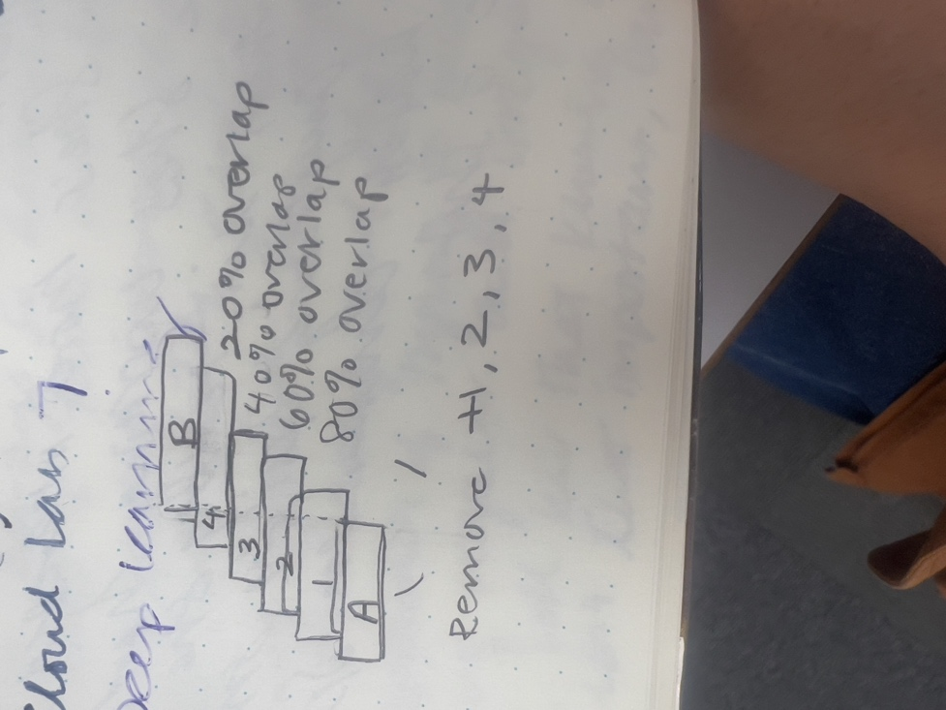
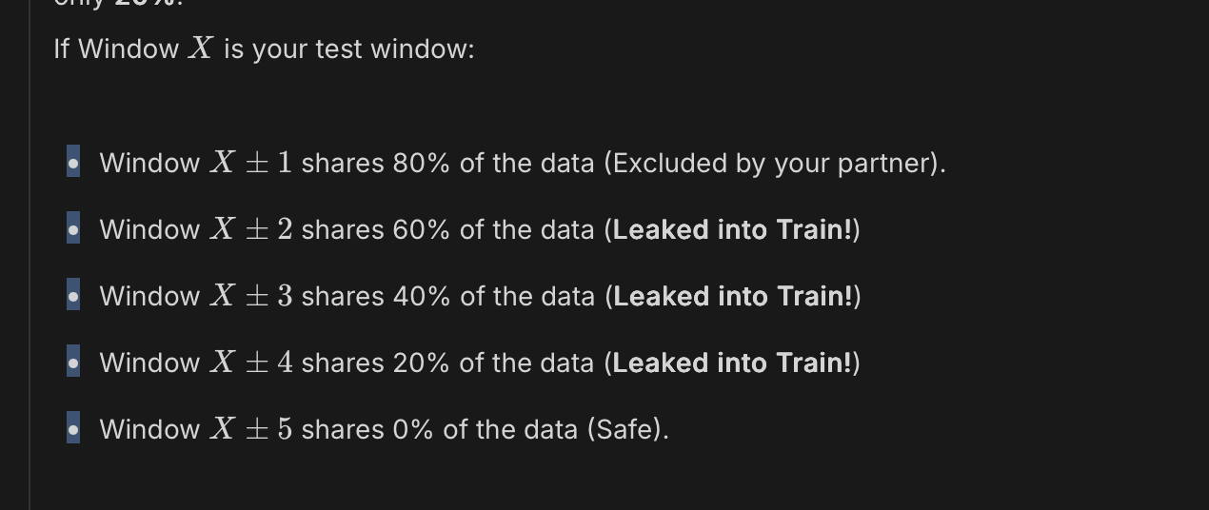
2. Deleting Data Unnecessarily (Applying to Normal Windows)
-normal windows do not have augmentation - PDF DatasetDescription states: "Non-ictal [normal] windows are non-overlapping".
In _build_window_assignments, we passed all test_ids (both normal and seizure windows) into this function. It looks up the chronological position of the window in the EDF file (file_pos) and flags the neighbors to be dropped. Because normal windows already have 0% overlap, there is absolutely no need to drop their neighbors. The exclusion logic should have had a filter to only apply to class_label == 1 (Seizure windows).
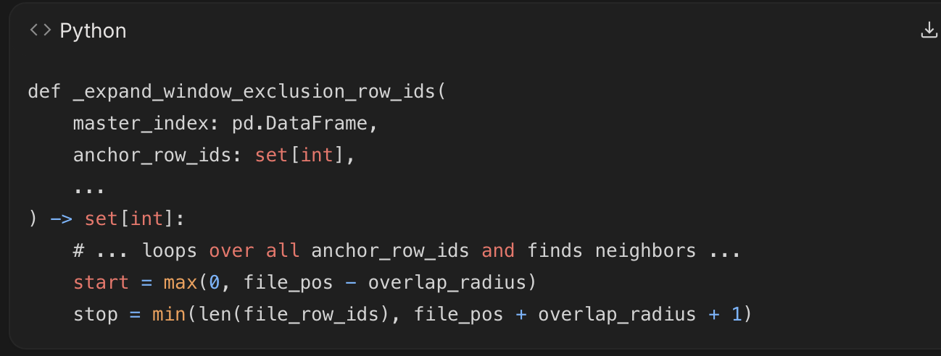

3. Ignoring Train vs. Validation Leakage
We forgot to apply the exclusion of overlapped data between the Train and Validation sets. Since validation set is used at the end of every epoch to calculate the metric (ROC-AUC) and decide if the model should trigger "Early Stopping", this affected training to overfit. Because train_pool and val_pool were split randomly, an 80%-overlapped seizure window might end up in val_pool while its neighbor is in train_pool. The CNN will simply memorize the overlapping signal, the validation AUC will falsely spike to 99% in the first few epochs, and the training script will save a strongly overfitted model.
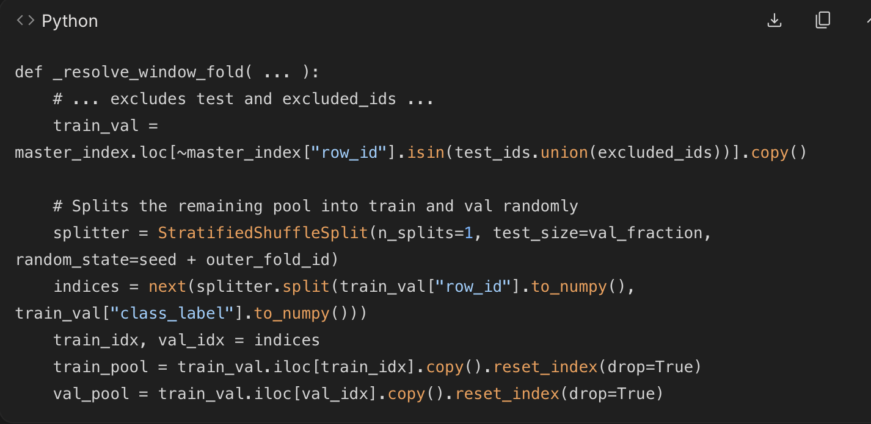

Fixes:
1. The chb01 and chb21 Patient Leakage Fix
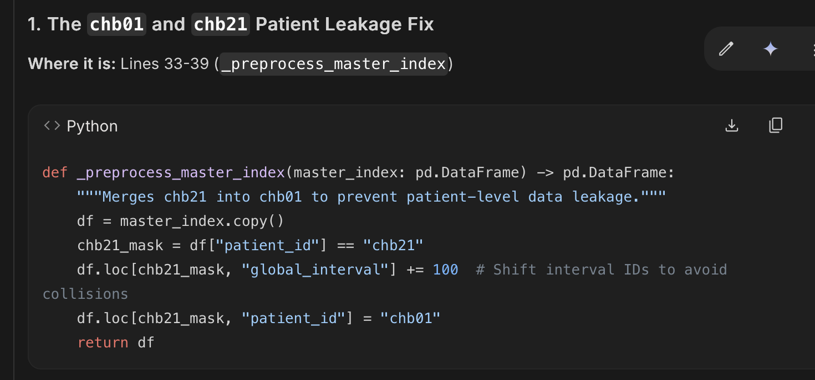
The ID Merge: By converting chb21 into chb01 dynamically at the very top of the script, every single downstream function (Patient splits, Seizure splits, etc.) now correctly treats them as the exact same human being. You don't have to rewrite the complex logic for the patient-fold splits.
The Interval Shift (+= 100): This is a crucial detail. Both chb01 and chb21 have a "Seizure 1", "Seizure 2", etc. If you just renamed the patient, the seizure folds would accidentally group chb01's first seizure and chb21's first seizure into the exact same fold. Adding 100 shifts chb21's seizures to 101, 102, etc., keeping them as distinct chronological events for the Seizure-level protocol.

2. The 80% Overlap Fix (Test vs. Train)
See _resolve_window_fold
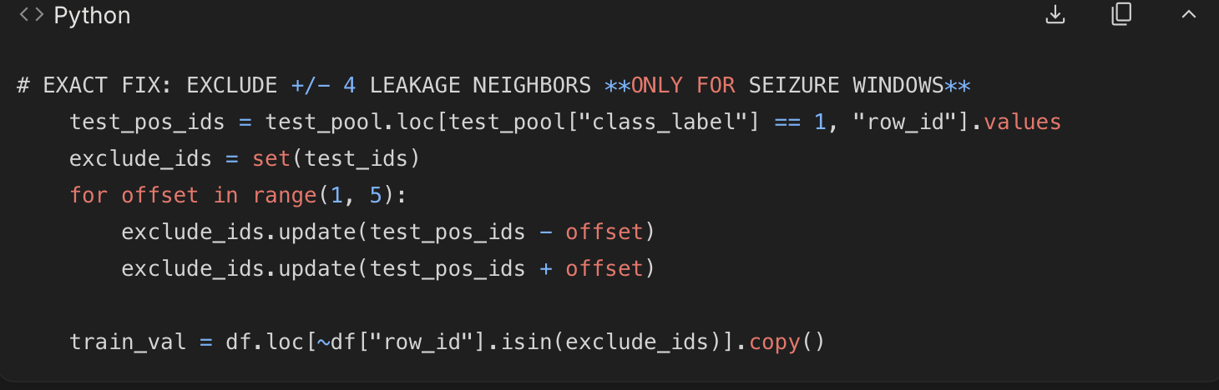

- The range(1, 5): This correctly implements the math. An 80% overlap means the sliding window advances by 20%. Therefore, neighbors at distances of 1 (80% overlap), 2 (60%), 3 (40%), and 4 (20%) are dropped. A distance of 5 has 0% overlap and is safe to keep.
- The class_label == 1 filter: Because normal windows (class 0) are contiguous and do not overlap, we only calculate offsets for test_pos_ids (the seizure windows). This ensures we eliminate 100% of the data leakage without throwing away any valid normal data.

3. The Hidden Overlap Fix (Validation vs. Train)

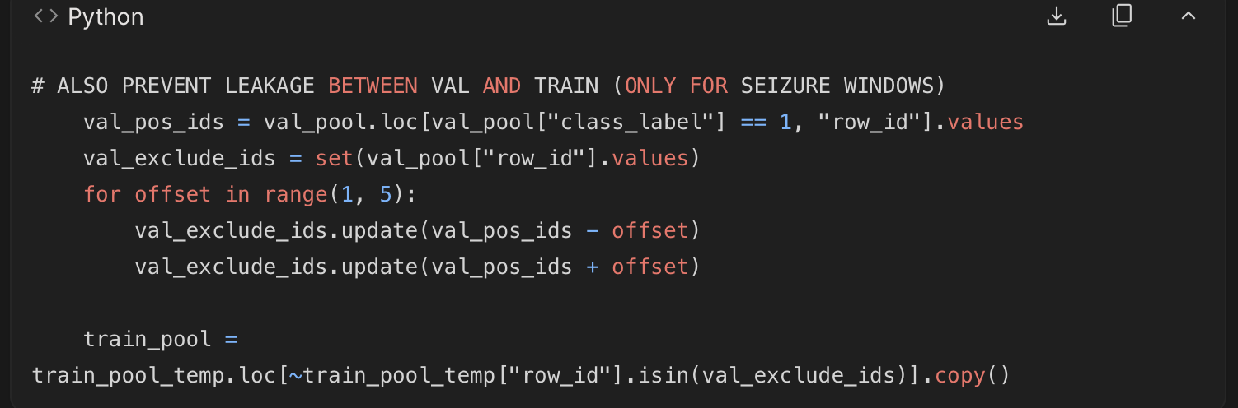
Protecting the Validation Set
Protecting the Validation Set: This is the part your partner completely missed. During training, deep learning models save their "best" checkpoint based on the validation score. If validation windows overlap with training windows, the model will "cheat," the validation AUC will hit 0.99 immediately, and it will save an overfitted model.

This block ensures the training pool train_pool is purged of any windows that overlap with the validation set val_pool, guaranteeing that the checkpoint saved by the CNN is genuinely generalizing to unseen data.

